**Kafka Installation**

1. **Prerequisites**
   1. 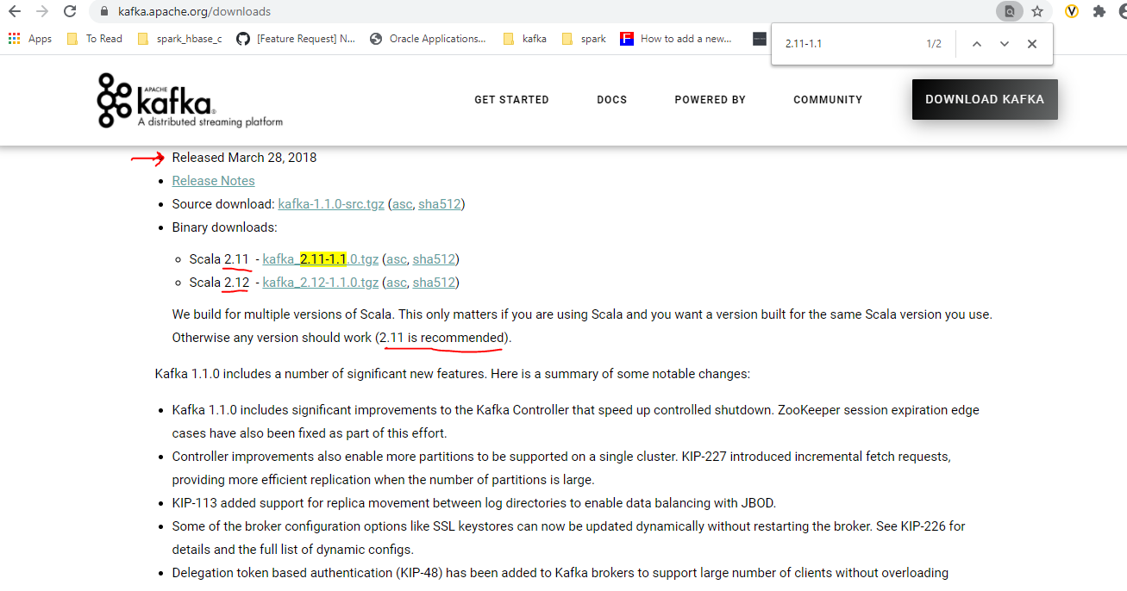Download kafka binaries
   2. Unzip binaries files in your kafka cluster servers

**tar** zxvf [kafka_2.11-1.1.0.tgz](https://archive.apache.org/dist/kafka/1.1.0/kafka_2.11-1.1.0.tgz)

* 1. Move unzipped files to /opt

**mv** kafka_2.11-1.1.1 **/opt**

1. **Installation Steps**
   1. **Zookeeper (set below settings on each zookeeper servers[87,88,89])**

**vi /opt/kafka_2.11-1.1.1/config/zookeeper.properties**

**- server 10.208.28.87**

# the directory where the snapshot is stored.

dataDir=/data/zookeeper-dataDir

# the port at which the clients will connect

clientPort=2181

# disable the per-ip limit on the number of connections since this is a non-production config

maxClientCnxns=0

initLimit=10

tickTime=3000

autopurge.purgeInterval=24

syncLimit=5

autopurge.snapRetainCount=30

server.1=0.0.0.0:2888:3888 #make it 0.0.0.0 on server(10.208.28.87) that own the **zookeeper.properties**

server.2=10.208.28.88:2888:3888

server.3=10.208.28.89:2888:3888

**- server 10.208.28.88**

dataDir=/tmp/zookeeper

# the port at which the clients will connect

clientPort=2181

# disable the per-ip limit on the number of connections since this is a non-production config

maxClientCnxns=0

initLimit=10

tickTime=3000

autopurge.purgeInterval=24

syncLimit=5

autopurge.snapRetainCount=30

server.2=0.0.0.0:2888:3888 #make it 0.0.0.0 on server(10.208.28.88) that own the zookeeper.properties

server.1=10.208.28.87:2888:3888

server.3=10.208.28.89:2888:3888

* **server 10.208.28.89**

# the directory where the snapshot is stored.

dataDir=/tmp/zookeeper

# the port at which the clients will connect

clientPort=2181

# disable the per-ip limit on the number of connections since this is a non-production config

maxClientCnxns=0

initLimit=10

tickTime=3000

autopurge.purgeInterval=24

syncLimit=5

autopurge.snapRetainCount=30

server.3=0.0.0.0:2888:3888 #make it 0.0.0.0 on server(10.208.28.89) that own the zookeeper.properties

server.1=10.208.28.87:2888:3888

server.2=10.208.28.88:2888:3888

* 1. **Start zookeeper**
     + 1. Run below command on all zookeepers server
          1. 10.208.28.87, 10.208.28.88, 10.208.28.89
          2. Note: Directory **/data/zookeeper-logs** must be exist first

-on server 10.208.28.87

**mkdir /tmp/zookeeper**

**echo "1" >/tmp/zookeeper/myid**

**mkdir /data/zookeeper-logs**

**nohup** **/opt/kafka_2.11-1.1.1/bin/zookeeper-server-start.sh** **/opt/kafka_2.11-1.1.1/config/zookeeper.properties** >> **/data/zookeeper-logs/serverLogs.log** &

-on server 10.208.28.88

**mkdir /tmp/zookeeper**

**echo "2" >/tmp/zookeeper/myid**

**mkdir /data/zookeeper-logs**

**nohup** **/opt/kafka_2.11-1.1.1/bin/zookeeper-server-start.sh** **/opt/kafka_2.11-1.1.1/config/zookeeper.properties** >> **/data/zookeeper-logs/serverLogs.log** &

-on server 10.208.28.89

**mkdir /tmp/zookeeper**

**echo "3" >/tmp/zookeeper/myid**

**mkdir /data/zookeeper-logs**

**nohup** **/opt/kafka_2.11-1.1.1/bin/zookeeper-server-start.sh** **/opt/kafka_2.11-1.1.1/config/zookeeper.properties** >> **/data/zookeeper-logs/serverLogs.log** &

* 1. **Kafka installations**
     1. **set below settings on each kafka broker servers**

10.208.28.87, 10.208.28.88, 10.208.28.89

**vi /opt/kafka_2.11-1.1.1/config/zookeeper.properties**

**- server 10.208.28.87**

broker.id=1

listeners=PLAINTEXT://10.208.28.87:9092

log.dirs=/data/kafka-logs

# The minimum age of a log file to be eligible for deletion due to age

log.retention.hours=24

# The interval at which log segments are checked to see if they can be deleted according

# to the retention policies

log.retention.check.interval.ms=300000

log.roll.ms=86400000

log.segment.bytes=104857600

zookeeper.connect=10.208.28.87:2181, 10.208.28.88:2181,10.208.28.89:2181

delete.topic.enable=true

**vi /opt/kafka_2.11-1.1.1/config/zookeeper.properties**

**- server 10.208.28.88**

broker.id=1

listeners=PLAINTEXT://10.208.28.88:9092

log.dirs=/data/kafka-logs

# The minimum age of a log file to be eligible for deletion due to age

log.retention.hours=24

# The interval at which log segments are checked to see if they can be deleted according

# to the retention policies

log.retention.check.interval.ms=300000

log.roll.ms=86400000

log.segment.bytes=104857600

zookeeper.connect=10.208.28.87:2181, 10.208.28.88:2181,10.208.28.89:2181

delete.topic.enable=true

**vi /opt/kafka_2.11-1.1.1/config/zookeeper.properties**

**- server 10.208.28.89**

broker.id=1

listeners=PLAINTEXT://10.208.28.89:9092

log.dirs=/data/kafka-logs

# The minimum age of a log file to be eligible for deletion due to age

log.retention.hours=24

# The interval at which log segments are checked to see if they can be deleted according

# to the retention policies

log.retention.check.interval.ms=300000

log.roll.ms=86400000

log.segment.bytes=104857600

zookeeper.connect=10.208.28.87:2181, 10.208.28.88:2181,10.208.28.89:2181

delete.topic.enable=true

-run below commands on all brokers server

**mkdir /data/kafka-logs**

**#on server 10.208.28.87**

**echo "broker.id=1" >> /data/kafka-logs/meta.properties**

**#on server 10.208.28.88**

**echo "broker.id=2" >> /data/kafka-logs/meta.properties**

**#on server 10.208.28.89**

**echo "broker.id=3" >> /data/kafka-logs/meta.properties**

**nohup /opt/kafka_2.11-1.1.1/bin/kafka-server-start.sh /opt/kafka_2.11-1.1.1/config/server.properties >> /data/kafka-logs/serverLogs.log &**